Name Date Class
Atoms and Bonding
Understanding Main Ideas
Look at the diagram below. Then answer the following questions in the space provided.
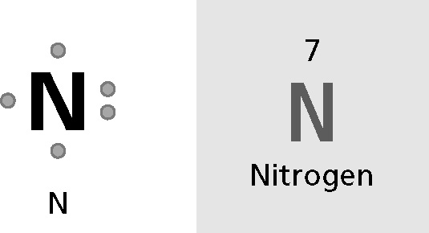
1. How many protons does a nitrogen atom have? _______________
2. How many valence electrons does a nitrogen atom have? _______________
3. Is nitrogen reactive or stable? ______________________________
4. Neon (Ne), which has an atomic number of 10 is in Group 18 in the periodic table. To which
group does nitrogen belong? _______________
5. The element directly below nitrogen in the periodic table is phosphorus (P). How many
valence electrons does phosphorus have? _______________
6. Will the properties of nitrogen be more similar to the properties of neon or the properties
of phosphorus? Explain.

Building Vocabulary
If the statement is true, write true. If the statement is false, change the underlined word
or words to make the statement true.
7. _______________ An element’s reactivity is determined by the
number of protons found in an atom of the element.
8. _______________ The force of attraction that holds two atoms
together is called a(n) chemical bond.
9. _______________ In a(n) periodic table, dots around an
element’s symbol indicate the number of valence electrons in
an atom.

Name Date Class
Atoms and Bonding
If the statement is true, write true. If the statement is false, change the underlined word
or words to make the statement true.
1. _______________ An atom’s valence electrons are those electrons that have the
highest energy.
2. _______________ Atoms tend to be stable and nonreactive if they have six
valence electrons.
3. _______________ In the periodic table, the number of valence electrons in each
element decreases from left to right across each period.
4. _______________ The reactivity of a metal depends on how easily it loses its
valence electrons.
5. _______________ Within each period in the periodic table, elements have similar
properties because they have the same number of valence electrons.
Fill in the blank to complete each statement.
6. The number of _______________________________________ in the atom of an element
determines its chemical properties.
7. The columns in the periodic table are called _______________.
8. A(n) _______________________________________ shows the number of valence
electrons in an atom in pictorial fashion.
9. The attractive force that holds two atoms together is called a(n)
_______________________________________.
10. Because it can either lose or share electrons when it combines with other elements,
each _______________ has some of the properties of metals and some of the
properties of nonmetals.

Name Date Class
Elements Forming Compounds
Write the letter of the correct answer on the line at the left.

1. ___ Ionic bonds form between two ions that
have
a ionic compounds
b negative charges
C positive charges
d opposite charges
3. ___ Compared to ionic compounds,
molecular compounds generally have
a a low boiling point
b greater densities
C more chemical bonds
d good conductivity

Fill in the blank to complete each statement.
5. A(n) _______________ is an atom or group of atoms that has an electric charge.
6. The attraction between oppositely charged ions is called a(n) _______________
_______________.
7. When an atom loses a valence electron, it becomes a(n) _______________ ion.
8. In order to have a stable arrangement of 8 valence electrons, metal atoms are likely
to _______________ electrons.
9. In an ionic compound, the total positive charge of all the positive ions
_______________ the total negative charge of all the negative ions.
10. Atoms form a _______________ bond by sharing one pair of electrons.

2. ___ Ions that are made of more than
one atom are called
a ionic compounds
b crystals
C polyatomic atoms
d ionic bonds
4. ___ Metallic bonding is
a a type of covalent bond
b a type of ionic bond
C an attraction between positive ions
and electrons
d an attraction between positive and
negative ions

Name Date Class
Classifying Chemical Compounds
Write the letter of the correct answer on the line at the left.

1. ___ Hard crystals, high melting points, and
electrical conductivity are properties of
a molecular compounds
b ionic compounds
C acids
d bases
3. ___ An acid has a pH value that is
a lower than 7
b equal to 7
C higher than 7
d none of the above

2. ___ Ammonia and baking soda are
common
a salts
b acids
C bases
d solutions
4. ___ The property of acids described as
the “wearing away” process is called
a erosion
b boiling point
C corrosion
d polar

If the statement is true, write true. If the statement is false, change the underlined word
or words to make the statement true.
5. _______________ The strength of the ionic bonds and the attractions among all
the ions make the crystals of ionic compounds hard and brittle.
6. _______________ The forces holding molecular compounds together are stronger
than the forces holding ionic compounds together.
7. _______________ When acids react with metals such as copper, zinc, and iron,
metals disappear and hydrogen gas is produced.
8. _______________ Ionic compounds have low boiling points because the
attraction between positive and negative ions is so great.
9. _______________ Chemists use indicators to test acids.
10. _______________ The forces between molecules are much stronger than the
forces between ions.

