Name Date Class
Earth in Space
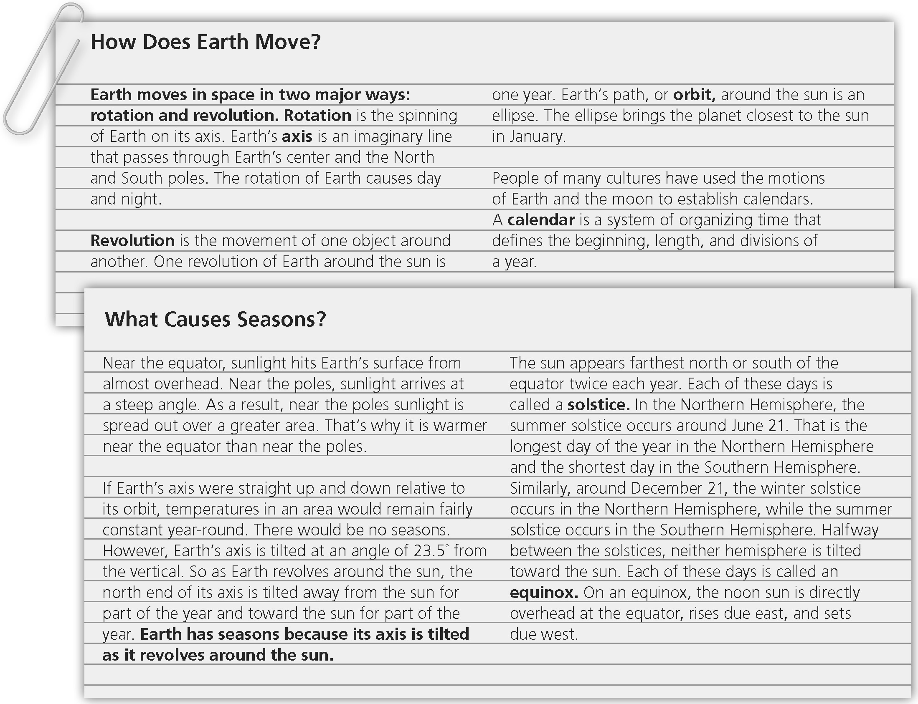
In one or more paragraphs, identify the two major ways Earth moves in space. Then,
explain (in detail) how the tilt of Earth’s axis affects the seasons.

Name Date Class
Phases and Eclipses
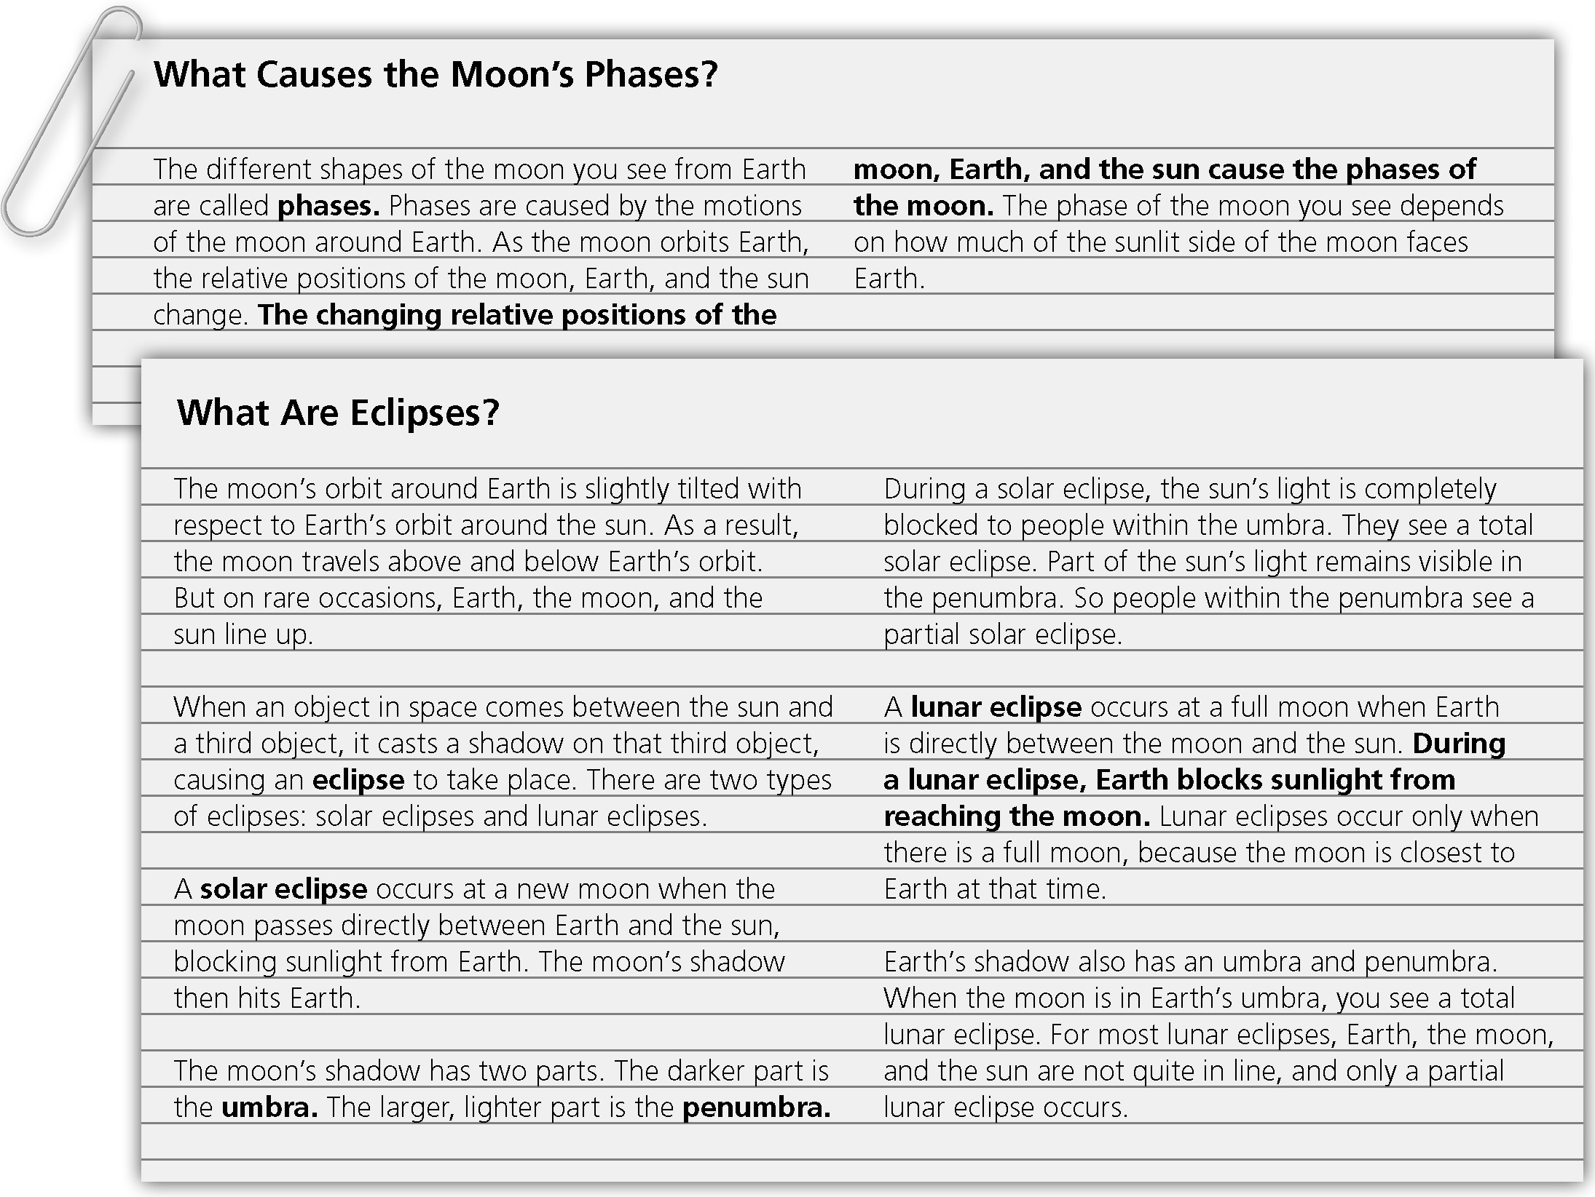
In one or more paragraphs explain (in detail) how interactions of the moon, Earth, and the sun cause the phases of the moon and eclipses.

