Chapter 2 Name ______________________________________________________
1. Fill out the three ring Venn diagram (below) to compare and contrast scientific hypotheses, theories, and laws. (How they are different goes in the outer parts of the circles. How they are the same goes in the inner parts of the circles.)
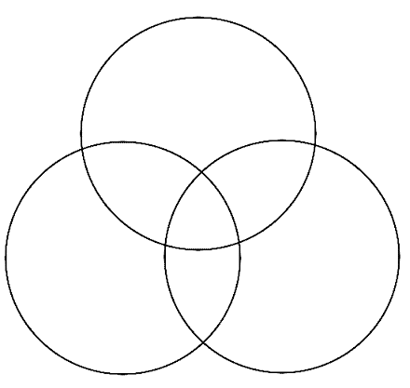
2. Recent studies show that you can actually be too clean. Overuse of hand sanitizers and antibacterial soaps kills not only harmful bacteria, but helpful bacteria as well. Make an objective AND a subjective statement about these studies.
3. How does science impact community, state, and national decisions?
4. How is pseudoscience different from real science? Explain.
5. What is a model and why would a scientist use one?

