Chapter 3 Questions Name ___________________________________________________________
Directions: CLOSE read the assigned reading and answer the questions. To receive full credit for this assignment you must answer the following questions AND list the paragraph number and page number where you found your answer.
Section 4 CLOSE Read pages 111-115
1. Stars are classified by

Paragraph Number___________ Page Number ____________
2. What two characteristics of stars are shown in an H-R diagram?

Paragraph Number___________ Page Number ____________
3. What is the relationship between brightness and temperature shown within the main sequence?

Paragraph Number___________ Page Number ____________
4. The star Procyon B has a surface temperature of 7,500ºC and a low absolute brightness. What type
of star is it?

Paragraph Number___________ Page Number ____________

Section 6 CLOSE Read pages 123-127
5. list List the layers of the sun’s interior and atmosphere, starting from the center.

Paragraph Number___________ Page Number ____________
6. What is one key difference between the radiation and convection zones?

Paragraph Number___________ Page Number ____________
7. Why do sunspots look darker than the rest of the sun’s photosphere?

Paragraph Number___________ Page Number ____________
8. How is the solar wind related to magnetic storms on Earth?

Paragraph Number___________ Page Number ____________

Name Date Class
The Sun
The diagrams below show how a series of sunspots behave over time. Read the passage
and study the diagrams. Then answer the questions that follow in the spaces provided.
Sunspot Clues
Although sunspots were once unexplained blemishes on the sun’s surface, their behavior has helped
solve some of the sun’s mysteries. One of these mysteries dealt with the rotation of the sun. Did it
rotate, as did other objects in the solar system? And, if it did rotate, what was its period of rotation?
Astronomers helped answer these questions by observing the behavior of sunspots.
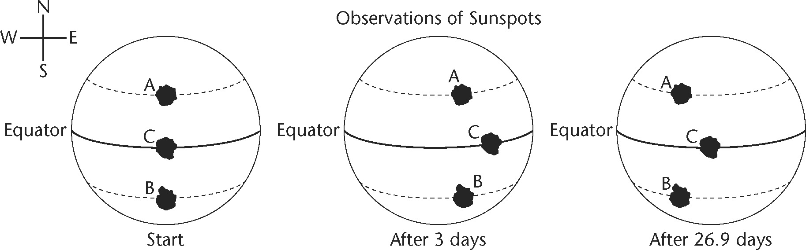
1. How have astronomers inferred that the sun rotates?

2. What direction does the sun rotate?

3. Sunspots at the equator take 26.9 days to move once around the sun.
What can you infer about how long sunspots A and B take to move
around the sun, compared to sunspot C, which is on the equator?

4. Why do astronomers say that the sun rotates once every
27 to 31 days, rather than give an exact number?

