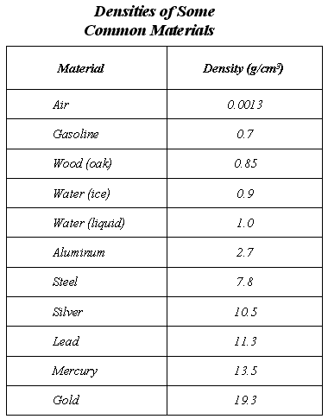
Name: ________________________________
Period: ____________________
4. 1. How does the density of liquid water compare with the density of ice?

5. 2. If samples of silver and lead each had volumes equal to 1 cm³, which sample would have the greater mass? What would the difference in the masses be?

6. 3. A 54-gram sample of an unknown material has a volume equal to 20 cm³. Based on its density, could the sample be aluminum? Explain.

7. 4. If gasoline is poured carefully into liquid water, will it sink or float? Explain why.

8. 5. What is the mass of 150 cm³ of liquid water? Explain.

9. 6. If a sample of a material has a mass of 21 grams and a volume equal to 2 cm³, could it be one of the substances listed in the table? Explain.

Name Date Class

Section 1 Measuring Matter
Write the letter of the correct answer on the line at the left.
1. ___ A balloon filled with air does not rise
as high as a balloon filled with helium.
What does this tell you about the density
of helium?
A helium is more dense than air.
B helium is less dense than air.
C the two gases have the same density.
D When heated, helium becomes more dense.
3. ___ The formula for calculating density is
A Mass × volume
B Mass × Weight
C 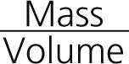
D 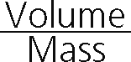
2. ___ The amount of matter in an object
is a measure of its
A volume
B density
C weight
D mass
4. ___ Which of the following statements
about the mass of an object is correct?
A Mass changes with location.
B Mass remains constant.
C Mass changes with altitude.
D Mass changes with gravity.
If the statement is true, write true. If the statement is false, change the underlined word
or words to make the statement true.
5. _____________ The SI unit of mass is the cubic meter.
6. _____________ One liter is equal to 100 milliliters.
7. _____________ An object’s weight is less on the moon than on Earth. On the
moon, the object’s mass decreases.
8. _____________ An object that floats in water has a density less than 1 g/mL.
9. _____________ Four measurable properties of matter are mass, weight,
volume, and pressure.
10. _____________ The SI unit of volume is the kilogram.

Name Date Class

Section 3 Physical and Chemical Changes
Fill in the blank to complete each statement.
1. _________________ is a chemical change that happens naturally in plants.
2. New substances are produced during a(n) _________________ change.
3. Fruit ripening is an example of a(n) _________________ change.
4. A substance that undergoes a chemical change produces a new substance with new
_________________.
5. Only the form or appearance of matter is altered during a(n) _________________ change.
If the statement is true, write true. If the statement is false, change the underlined word
or words to make the statement true.
6. _________________ Iron rusting is an example of a(n) physical change.
7. _________________ Glass breaking and sugar dissolving are examples of chemical
changes.
8. _________________ A substance that undergoes a physical change is still the same
substance after the change.
9. _________________ Liquid water changing into gas is an example of a(n) physical
change.
10. _________________ The chemical change that occurs when fuels are burned is
called oxidation.

