Science Chapter 7 Homework Name____________________________________
Section 1 Describing Matter (worth 100 points)
1. Find 10 items around your house and list them.
2. List at least 2 of the elements that they are made of (If you do not know, look it up! You can use the periodic table in your book-p. 320 or the internet)
____________________________________________________________________________________
____________________________________________________________________________________
____________________________________________________________________________________
____________________________________________________________________________________
____________________________________________________________________________________
____________________________________________________________________________________
____________________________________________________________________________________
____________________________________________________________________________________
____________________________________________________________________________________
____________________________________________________________________________________
3. Can these elements be broken down into other substances? EXPLAIN.
____________________________________________________________________________________
____________________________________________________________________________________
____________________________________________________________________________________
4. What is the difference between a mixture and a compound?
____________________________________________________________________________________
____________________________________________________________________________________
Section 2 States of Matter (worth 100 points)
1. List something in your kitchen that is a crystalline solid.
____________________________________________________________________________________
2. List something in your kitchen that is an amorphous solid.
____________________________________________________________________________________
3. Fill out the Venn diagram and compare solids, liquids, and gases. (List at least one phrase for each section)
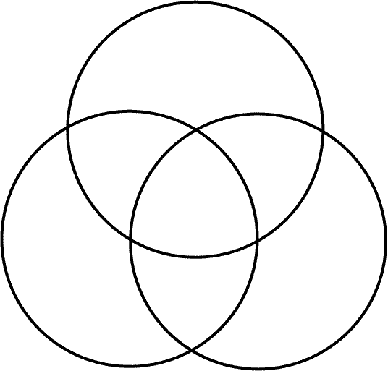
4. How do liquids with high viscosity differ from liquids with low viscosity? EXPLAIN. ____________________________________________________________________________________
____________________________________________________________________________________
____________________________________________________________________________________
5. Why does pumping more air into a football or basketball increase the pressure inside the ball? EXPLAIN.
____________________________________________________________________________________
____________________________________________________________________________________
____________________________________________________________________________________
Section 3 Changes of State (worth 100 points)
1. How does what happens to the particles in a substance during melting differ from what happens in freezing? EXPLAIN.
____________________________________________________________________________________
____________________________________________________________________________________
____________________________________________________________________________________
2. How does thermal energy differ from temperature? ____________________________________________________________________________________
____________________________________________________________________________________
3. What determines an object’s temperature?
____________________________________________________________________________________
____________________________________________________________________________________

Use the figure below to answer the following questions in the spaces provided.

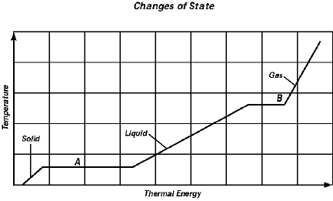
4. What states of matter of a pure substance are represented in the graph?
____________________________________________________________________________________
5. What happens to each of the variables—temperature and thermal energy—during the changes indicated by line segments A and B?
____________________________________________________________________________________

