Name Date Class
4.4 Geologic Time
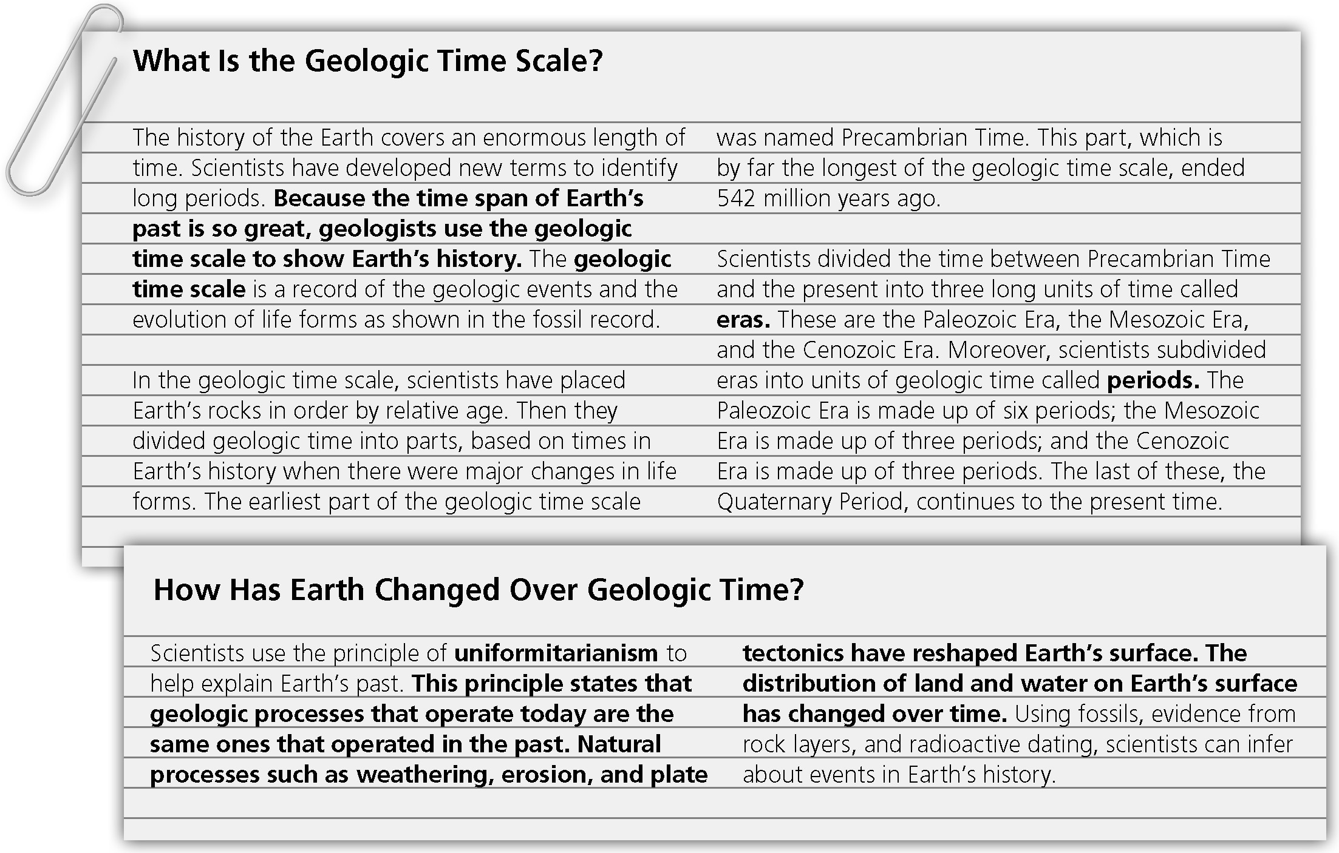
Summarize how scientists classify and study geologic time in 5 sentences or more.
__________________________________________________________________________________________________________________________________________________________________________________________________________________________________________________________________________________________________________________________________________________________________________________________________________________________________________________________________________________________________________________________________________________________________________________________________________________________________________________________________________________________________________________________________________________________________________________________________________________________________________
Name Date Class
5. 3 The Theory of Plate Tectonics
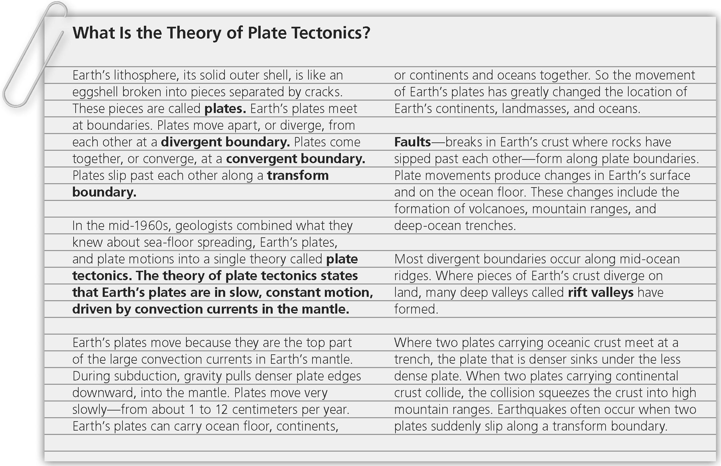
Summarize the changes to Earth’s surface that occur as a result of plate movements in 5 sentences or more.
__________________________________________________________________________________________________________________________________________________________________________________________________________________________________________________________________________________________________________________________________________________________________________________________________________________________________________________________________________________________________________________________________________________________________________________________________________________________________________________________________________________________________________________________________________________________________________________________________________________________________________
Name Date Class
6.1 Volcanoes and Plate Tectonics
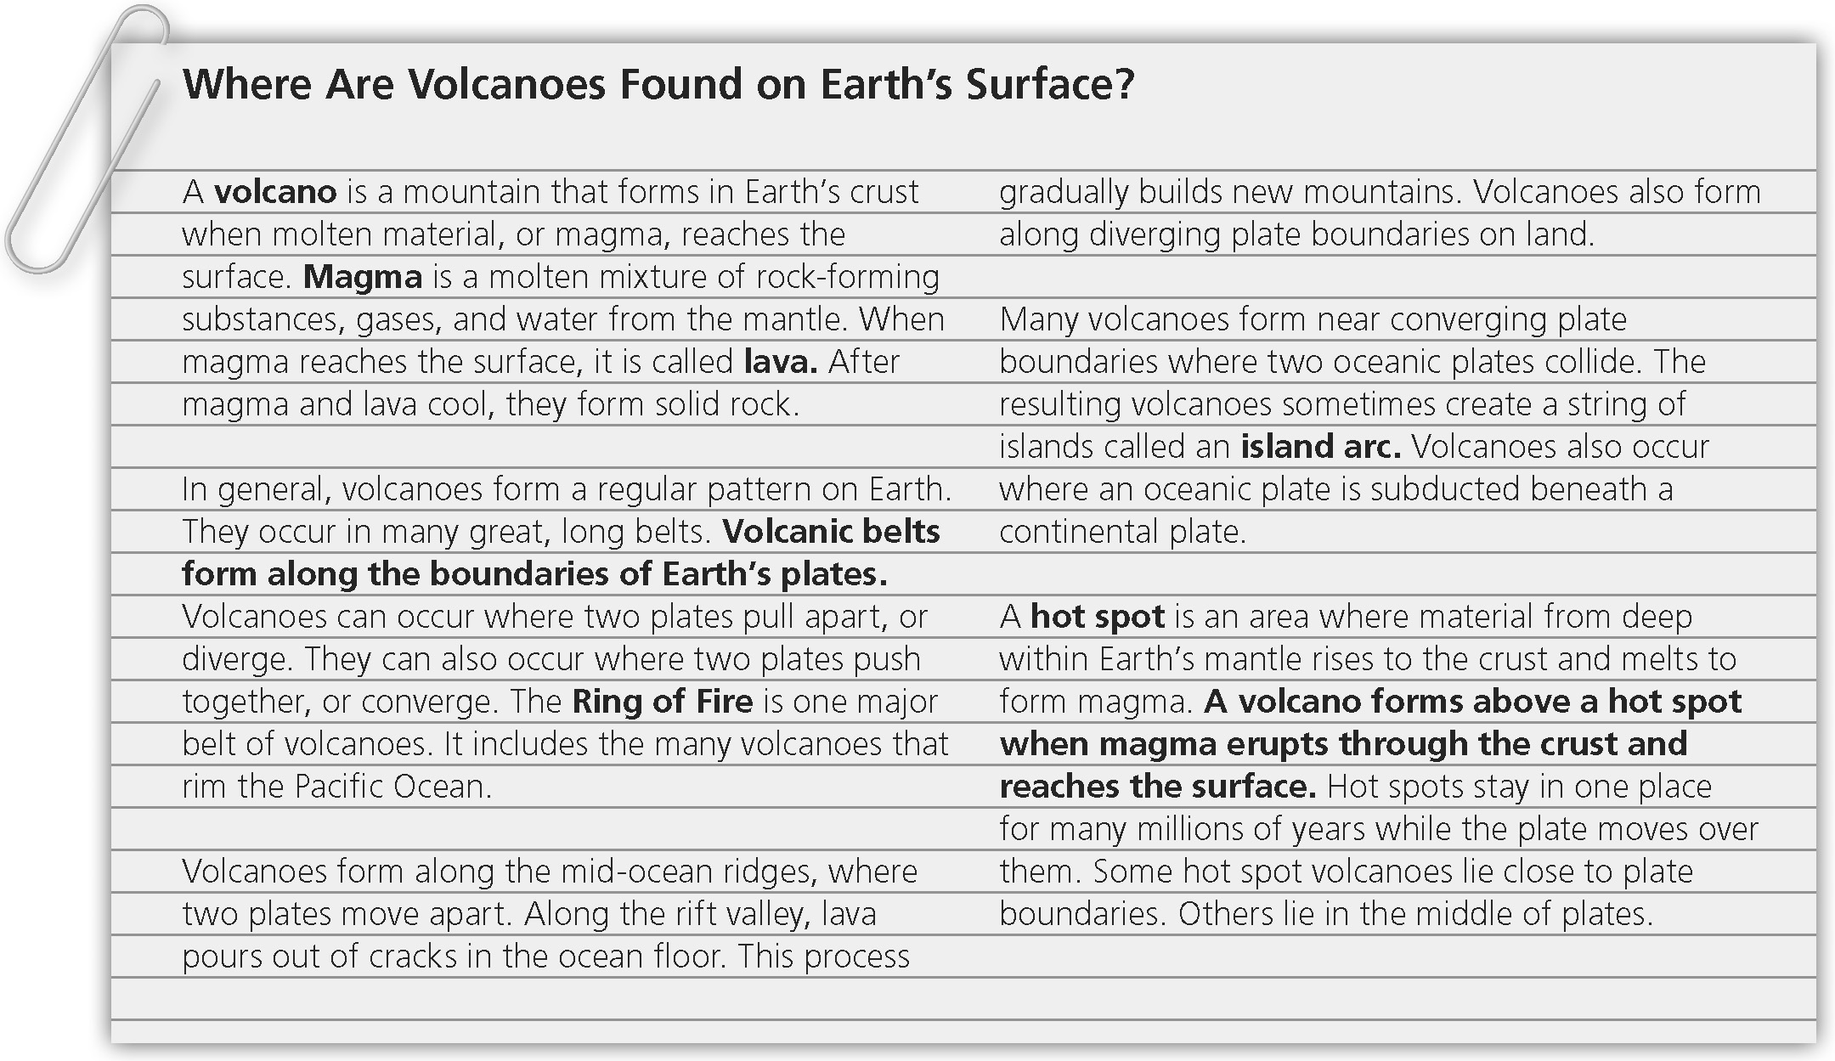
Summarize how plate tectonics plays a role in the formation of volcanoes in 5 sentences or more.
____________________________________________________________________________________________________________________________________________________________________________________________________________________________________________________________________________________________________________________________________________________________________________________________________________________________________________________________________________________________________________________________________________________________________________________________________________________________________________________________________________________________________________________________________________________________________________________________________________________________________________________________________________________________________________________________________________________________________________________________________________
Name Date Class
Forces in Earth’s Crust
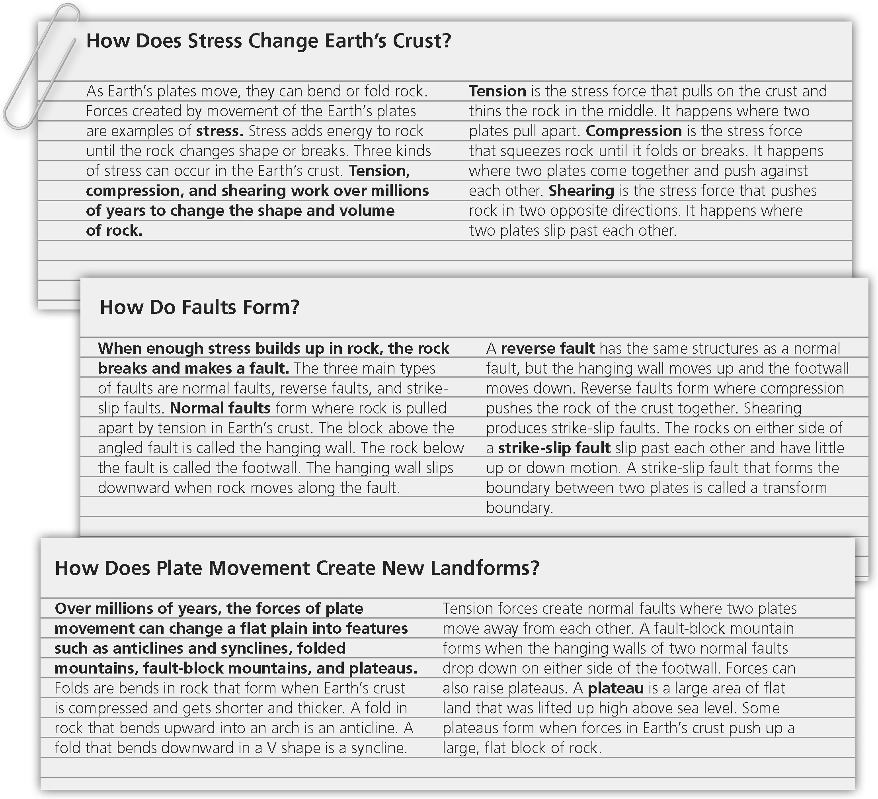
Explain how stress causes movement at faults in 5 sentences or more.
_________________________________________________________________________________
_____________________________________________________________________________________________________________________________________________________________________________________________________________________________________________________________________________________________________________________________________________________________________________________________________________________
Name Date Class
9.2 Balanced and Unbalanced Forces
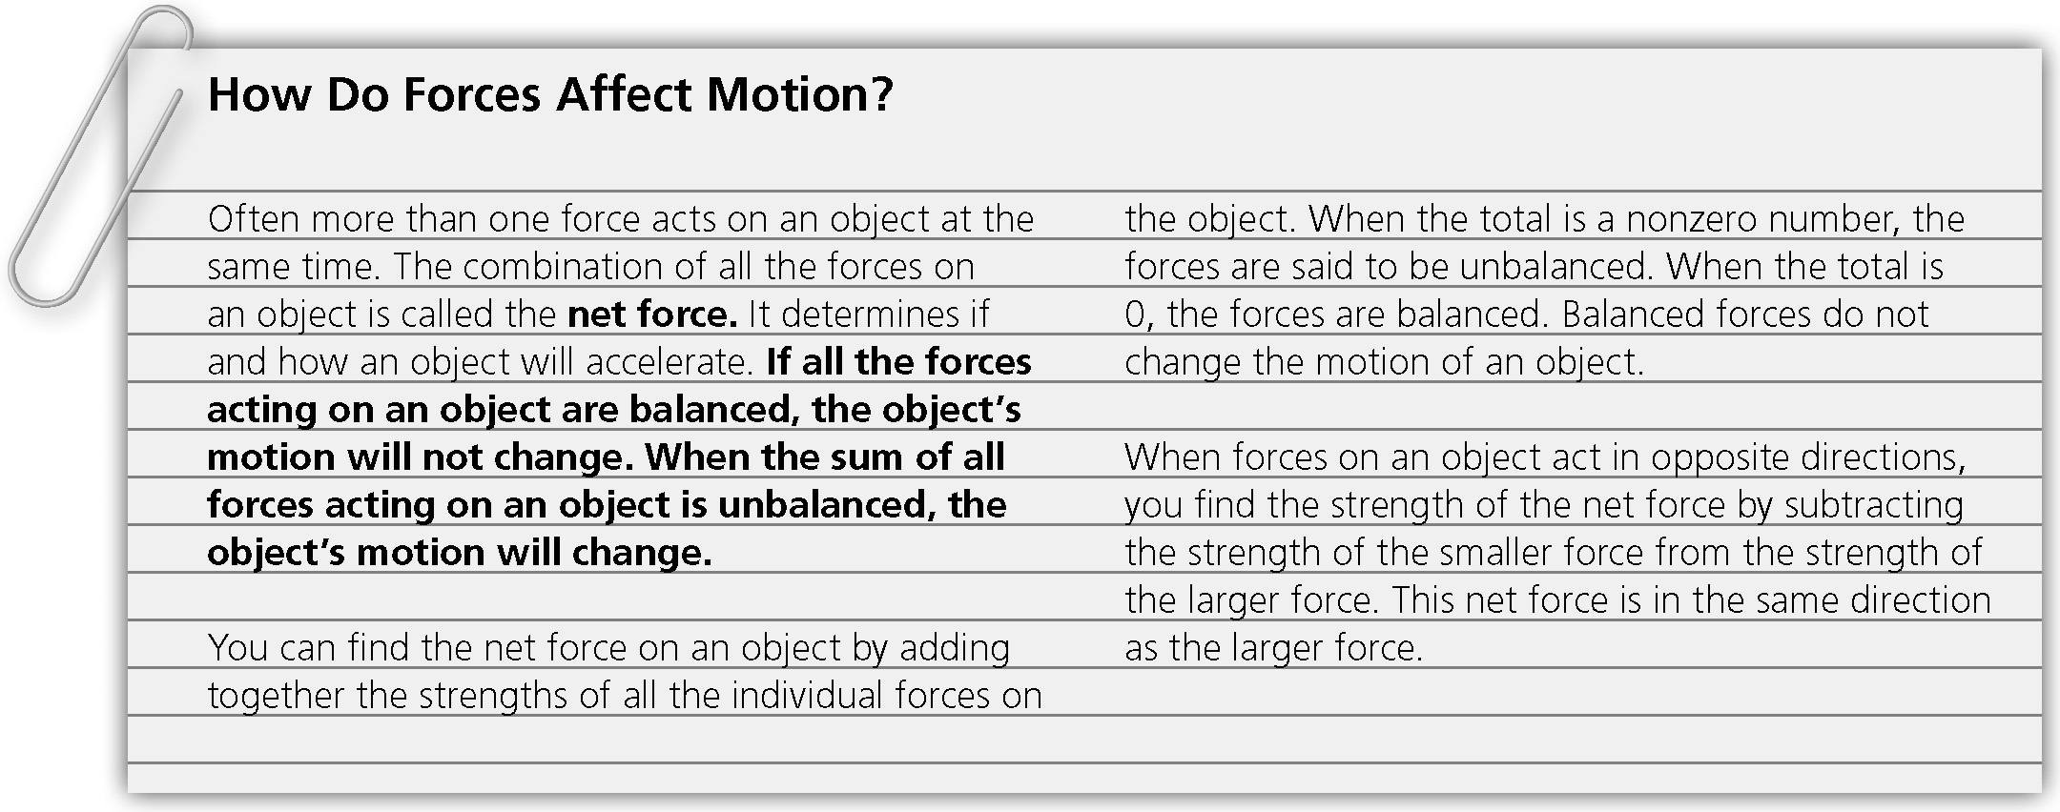
You push on one side of an open door with a force of 120 N. Your friend pushes on the
other side of the door with an equal force. Explain how these two forces affect the motion of the door.
_________________________________________________________________________________
_____________________________________________________________________________________________________________________________________________________________________________________________________________________________________________________________________________________________________________________________________________________________________________________________________________________
________________________________________________________________________________________________________________________________________________________________________________________________________________________________________________________________________________________________________________________________________________________________________________________________________________________________________________________________________________________________________________________________________________________________________________________________________________________________________________________________________

